***MEMORIAL HARE SCRAMBLE***

**SPONSORED BY:**

**FIVE STAR CYCLE AND HILLSIDE MOTOCROSS CLUB**

**DIRT BIKE RIDERS WELCOME**

**SUNDAY SEPTEMBER 13, 2015**

**FIVE STAR CYCLE / HILLSIDE MOTOCROSS CLUB**

**GATES OPEN AT 7:00 AM**

**REGRISTRATION 8:00-11:30AM**

**“C” CLASS RACE BEGINS 10:00 AM**

**“A, B” CLASS RACE BEGINS 12:00 PM**

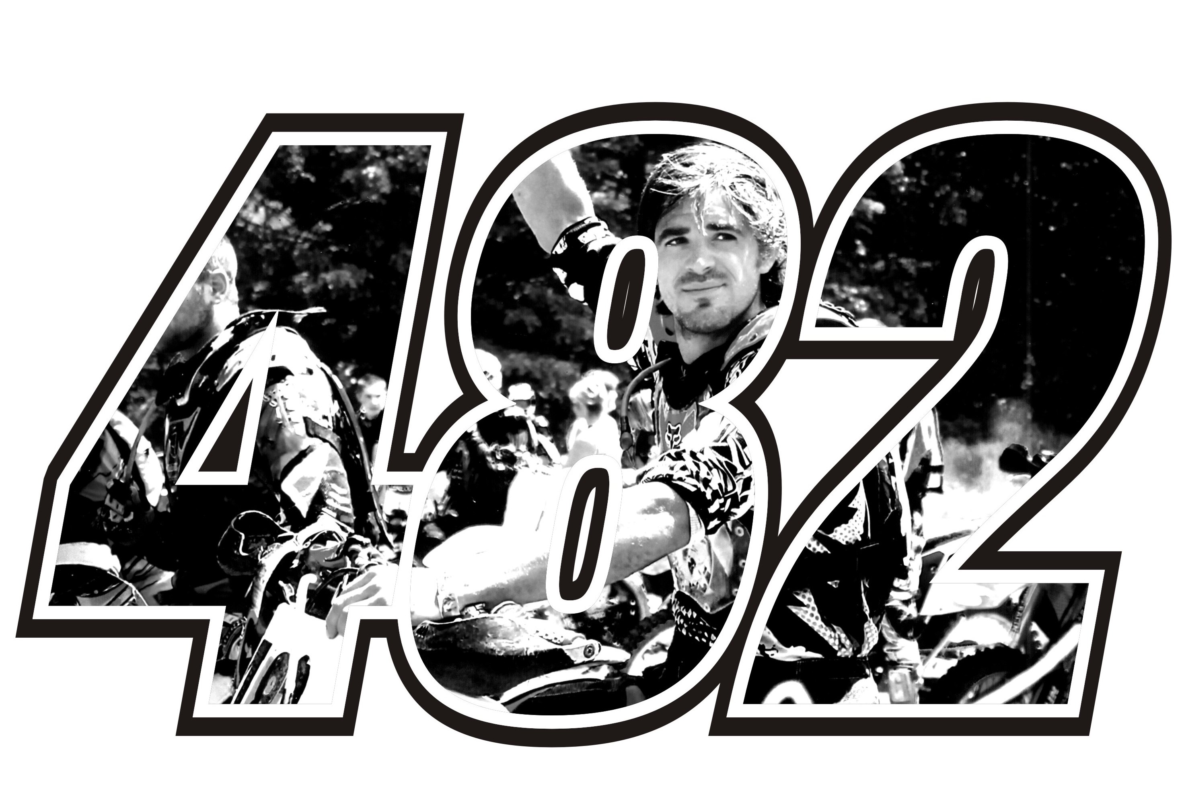

* **GATE FEE $10.00 PER PERSON**

**(UNDER 5 FREE)**

* **RACE FEE $25.00 PER RIDER**
* **CAMPING AVAILABLE**
* **NO 4 WHEELERS**
* **NO RIDERS UNDER 16**

**\*\*\*\*\*ENTER AT YOUR OWN RISK\*\*\*\*\***

**More information contact Melissa or Andrew Wells (814)323-3005**

Five Star Cycle: 21114 Fry Road  Saegertown, PA 16433 (814) 763-2453

Take exit **166** for **US-6N E** toward **Edinboro** Turn left onto **US-6N E** Turn right onto **Fry Rd**